Mathematics Specialist Unit 3

Test 2: Functions & Sketching Graphs
Solutions

Student Name: _________________________

Section I – calculator-free section solutions

Question 1. (3 marks)

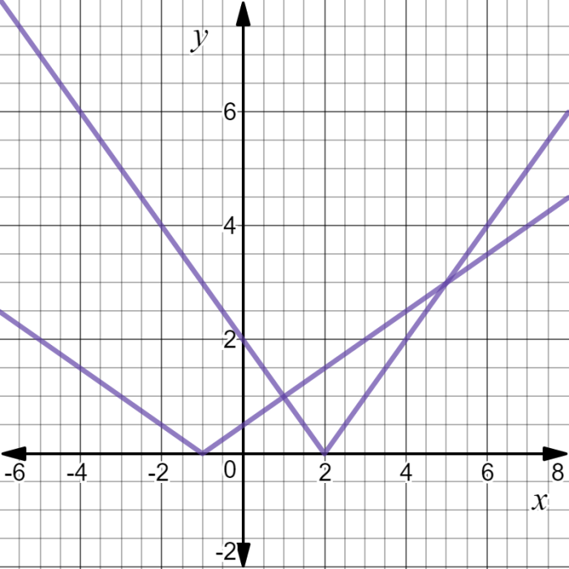
Use the diagram opposite to assist you to solve:

- $0.5\left|x+1\right|≤2$

$-5≤x≤3$

- $2-x=0.5\left|x+1\right|$

$x=1$

- $\left|2-x\right|>0.5\left|x+1\right|$

$x<1 or x>5$

Question 2. (4 marks)

Consider the nature of the graph of $y=$ $\frac{x^{2}+x-6}{x^{3}+4x^{2}+3x}$ . Describe the effect on the y values of the
graph as
= $\frac{(x+3)(x-2)}{x(x+3)(x+1)}$ = $\frac{x-2}{x(x+1)}$ , $x≠-3$

- x tends to $-∞$ $y⟶0^{-}$

- x tends to ${-3}^{+}$ $y⟶$ $\frac{-3-2}{-3(-3+1)}$ = $-\frac{5}{6}$
- x tends to $-1^{-}$ $y⟶-∞$ $\frac{x-2}{x(x+1)}=\frac{-ve}{-ve×-ve}$ $=-ve$

- x tends to $-2^{-}$ $y⟶-2$ $\frac{x-2}{x(x+1)}=\frac{-4}{-2\left(-1\right)}$ $=-2$

Question 3. (3 marks)

The graph of $y=\left|x-3\right|-2$ is shown below. Find $b$and $c such that the solution to the$equation

$\left|x-3\right|-2=-\left|x+b\right|+c$ is $x=-2, 9$.
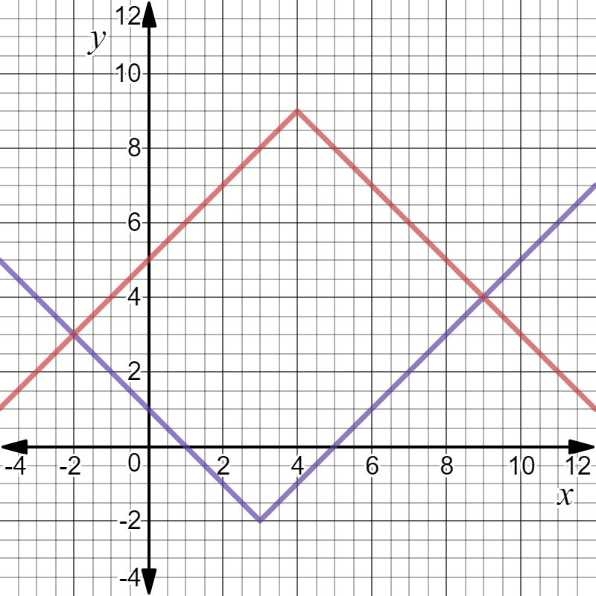

Gradient $±1 ⇒$vertex at $\left(4,9\right)⇒b=-4, c=9$

Question 4. (4 marks)

If $f\left(x\right)=3-$ $\frac{2}{x}$ determine

- $f^{-1}(4)$ Put $4=$ $3-$ $\frac{2}{x}$ $⟹$ $-1=$ $\frac{2}{x}$ $⟹$ $x=-2$ (2)

$∴(-2$ , 4)$∈ f ⟹$ $\left(4 , -2\right) ∈ f^{-1}$

$f^{-1}\left(4\right)= -2$

- The value(s) of x such that $f^{-1}(x)=f(x)$. (2)

${ f}^{-1}\left(x\right)=f\left(x\right)=x$
$∴$ $3-$ $\frac{2}{x}$ $=x$
$3x-2=x^{2}$
$0=x^{2}-3x+2$
$0=(x-2)(x-1)$
$x=1,2$

Question 5. (4 marks)

If $f\left(x\right)=x^{2}+2$and $g\left(x\right)=$ $\frac{1}{x+3}$ find the natural domain and corresponding range for

- fog(x) = $\frac{1}{{(x+3)}^{2}}$ + 2 (2)

$x≠-3 \underset{→}{g} y≠0 \underset{→}{ f} y>2$
$x+3≠0$

$dom(fog)=\left\{x:x∈R,x≠-3\right\}$

$ran(fog)=\left\{y:y∈R,y>2\right\}$

- gof(x) = $\frac{1}{x^{2}+5}$ (2)

$x∈R \underset{→}{f} y≥2 \underset{→}{g} 0< y≤\frac{1}{5}$
$x^{2}+2≥2$
$dom(gof)=\left\{x:x∈R\right\}$
$ran(gof)=\left\{y:y∈R,0<y≤\frac{1}{5}\right\}$

Question 6. (4 marks)

Find an expression for the inverse function of $p$ where $p\left(x\right)=4+$ $\frac{1}{2+x}$ and state the domain and range of $p^{-1}$ .

$y=4+$ $\frac{1}{2+x}$ , $x≠-2 , y≠4$

invert $⇒$ $x=4+$ $\frac{1}{2+y}$ $⇒ x-4=$ $\frac{1}{2+y}$ $⇒$ 2+y = $\frac{1}{x-4}$ $⇒ y=$ $\frac{1}{x-4}$ $–2$

${∴ p}^{-1}(x)=$ $\frac{1}{x-4}$ $–2$

$dom p^{-1}=\left\{x:x∈R,x≠4\right\}$
$ran p^{-1}=\left\{y:y∈R,y≠-2\right\}$

End of Section One
Section II – calculator-assumed section solutions

Question 7. (4 marks)

The graph of $y=f(x)$ is shown below in diagram (a). Show the graph of $y=\left|f(\left|x\right|)\right|$ in diagram (b).

(a) (b)

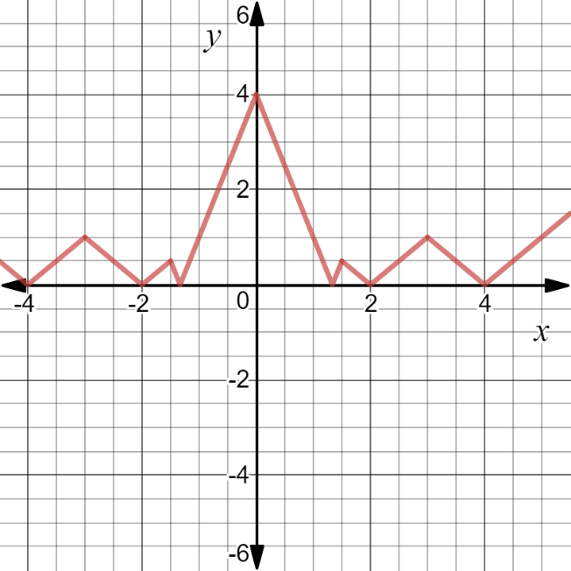
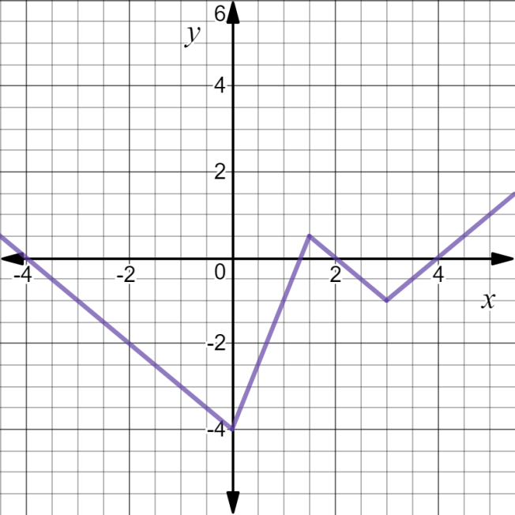

Question 8. (3 marks)

Find an expression for the inverse function of $q(x)$ where $q\left(x\right)=5-$ $\frac{1}{2x-3}$ and state its
domain and range.

$y=5-$ $\frac{1}{2x-3}$ $⇒$ $x=5-$ $\frac{1}{2y-3}$ $⇒$ $y=$ $\frac{3x-16}{2(x-5)}$

$∴$ $q^{-1}(x)=$ $\frac{3x-16}{2(x-5)}$ Use solve ($x=5-$ $\frac{1}{2y-3} ,y)$ on classpad

$dom q=\left\{x:xϵR,x≠\frac{3}{2}\right\}$ $∴ran{ q}^{-1}=\left\{y:yϵR,y≠\frac{3}{2}\right\}$

$ran q =\left\{y:yϵR,y≠5\right\}$ $∴dom{ q}^{-1}=$ $\left\{x:xϵR,x≠5\right\}$

Question 9. (4 marks)

Consider the graph of $y=$ $\frac{4x^{2}+4x}{x^{3}+x^{2}-4x-4}$ $=$ $\frac{4x(x+1)}{\left(x-2\right)\left(x+2\right)(x+1)}$ = $\frac{4x}{(x-2)(x+2)}$ , $x≠-1$

- Locate any asymptotes. $vertical asymptote x=-2,2$ (2)
$horizontal asymptote y=0$

- Describe any other discontinuities.$\frac{4\left(-1\right)}{\left(-3\right)×1} = \frac{4}{3}$ (2)
$∴$open circle at point $(-1, 1\frac{1}{3}$)

Question 10. (6 marks)

Determine all of the asymptotes for each of the following functions:

- F(x) = $\frac{x^{2}+2x}{x-1}$ (2)

$vertical asymptote x=1$
$oblique asymptote y=x+3$

- G(x) = $\frac{x^{2}-4}{x(x+2)}$ = $\frac{(x-2)(x+2)}{x(x+2)}$ = $\frac{x-2}{x}$ , $x≠-2$ (2)

$vertical asymptote x=0$
$horizontal asymptote y=1$

- H(x) = $\frac{{2x}^{2}+1}{(x-1)(x+2)}$ (2)

$vertical asymptote x=-2,1$
$horizontal asymptote y=2$

Question 11. (5 marks)
The graph of $y=h(x)$ is shown below. It has asymptotes at $x=0, x=4, y=$ $\frac{2}{5}$ . On the next set of axes draw the graph of $y=$ $\frac{1}{h(x)}$ , clearly showing any roots and asymptotes.

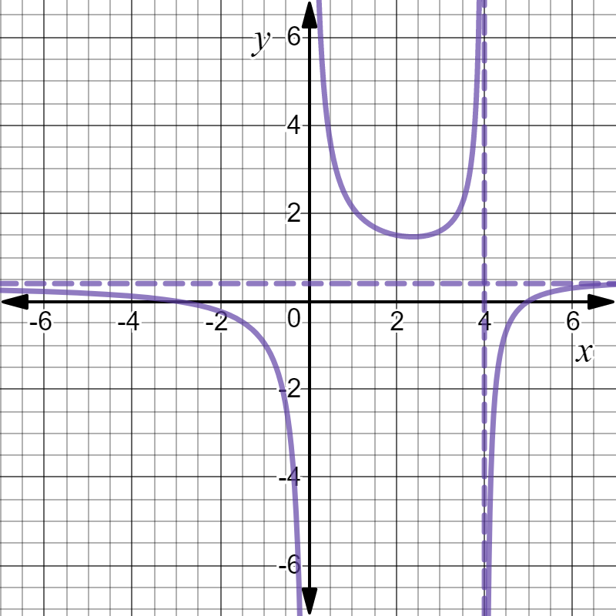

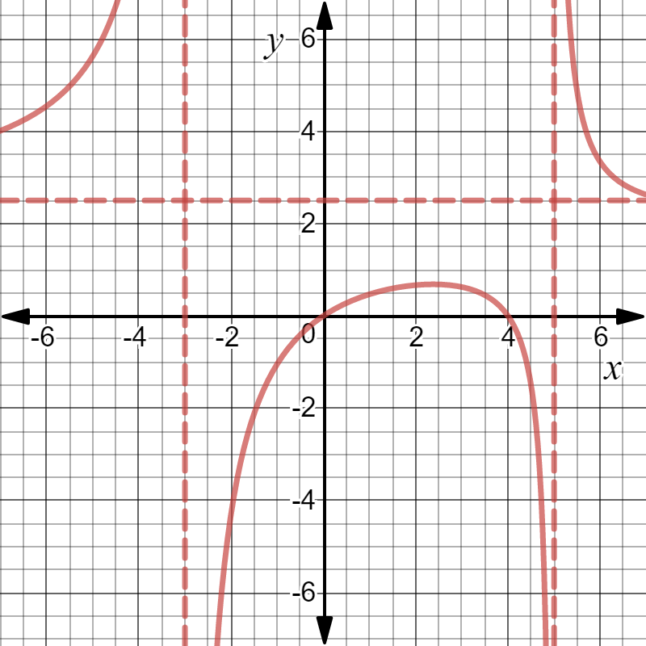

Roots at $x=0, 4$
Asymptotes at $x=-3 , x=5$ and $y=$ $\frac{5}{2}$
Turning point at $≈(2.4,0.7)$
Graph $y= \frac{1}{h(x)}$ has same x values as $y=h(x)$ at points with y-ordinates $y=-1, 1$
i.e. $≈(-1.0,-1$) and $≈(4.4,-1)$
Question 12. (7 marks)

The graph of $g\left(x\right)=$ $\frac{(x-6)(x+1)}{x-3}$ , $x<3$ has asymptotes $x=3 and y=x-2$ as is shown below:

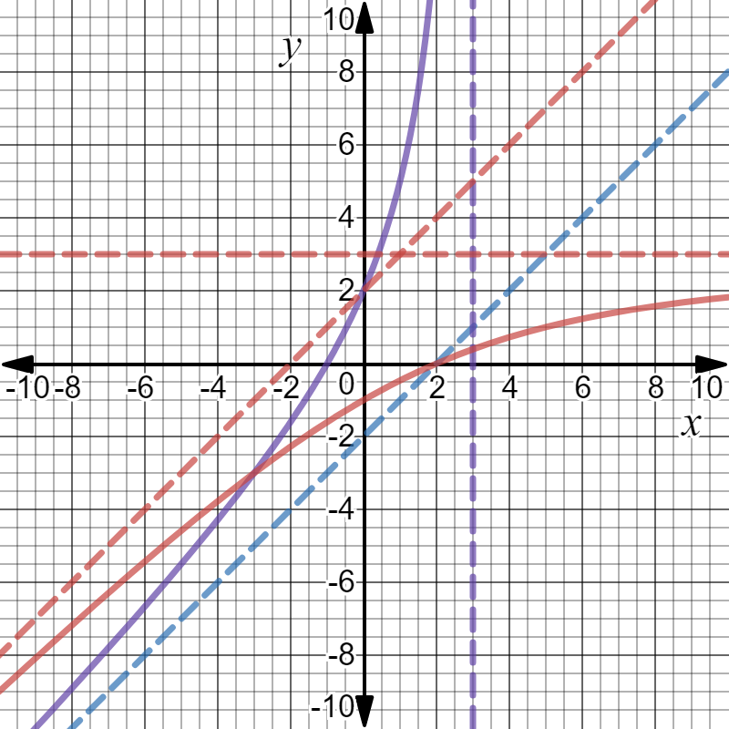

Asymptotes, curve symmetry in line $y=x$, curves meet at $(-3,-3)$

- Explain why $g$ has an inverse function $g^{-1}$ and find $g^{-1}(0)$ . (2)

$g$ is a one to one function

$g$ passes through $\left(-1, 0\right) ∴ g^{-1}$ passes through $(0, -1)$

${ g}^{-1}\left(0\right)=-1$

- Sketch the graph of $y=g^{-1}(x)$ on the same set of axes above. Include any
asymptotes in your sketch. (3)
The graphs, including asymptotes, of $g$ and $g^{-1}$ have symmetry about the line $y=x.$

- Solve for $x ,$ $g^{-1}\left(x\right)=1.5$. (2)

$∴gog^{-1}\left(x\right)= g(1.5)$

$∴ x = g(1.5)$

$∴ x =$ $\frac{\left(1.5-6\right)\left(1.5+1\right)}{1.5-3}$

$∴ x = 7.5$
Question 13. (4 marks)
Given that $p\left(x\right)=x^{2}-1$ and $q\left(x\right)=$ $\frac{3}{x}$ state the natural domain and the corresponding
range of each of the following functions:

- $poq(x)$ = $\frac{9}{x^{2}}$ $-1$ (2)

$dom poq=\left\{x:xϵR, x≠0\right\}$
$ran poq=\{y:yϵR, y>-1\}$

- $qop(x)$ = $\frac{3}{x^{2}-1}$ (2)

$dom qop=\left\{x:xϵR, x≠-1,1\right\}$
$ran qop=\{y:yϵR, y≤-3 or y>0\}$

End of Test Paper

